附件1
2023年柘荣县新任教师公开
招聘拟参加面试资格复审对象名单
招聘  岗位 | 招聘  人数 | 姓名 | 准考证号 | 笔试成绩 |  |  |  | 名次 | 备注
 |  |  |  | 原始笔试成绩 | 百分制  成绩 | 加  分 | 小计
幼儿教育教师 | 2 | 余*珠 | 696123100448 | 114.8 | 76.53 |  | 76.53 | 1
 |  | 程*琦 | 696123100380 | 113.9 | 75.93 |  | 75.93 | 2
 |  | 林*婷 | 696123100201 | 113.4 | 75.60 |  | 75.60 | 3
 |  | 吴*怡 | 696123100906 | 113.0 | 75.33 |  | 75.33 | 4
 |  | 林*娟 | 696123100842 | 108.9 | 72.60 |  | 72.60 | 5
 |  | 郑*玲 | 696123100780 | 106.7 | 71.13 |  | 71.13 | 6
小学语文教师 | 2 | 黄*玲 | 691123101662 | 99.4 | 66.27 |  | 66.27 | 1
 |  | 王*海 | 691123101475 | 96.6 | 64.40 |  | 64.40 | 2
 |  | 张*虹 | 691123101744 | 94.5 | 63.00 |  | 63.00 | 3
 |  | 郑*燕 | 691123101770 | 90.0 | 60.00 |  | 60.00 | 4
 |  | 陈* | 691123101931 | 86.7 | 57.80 |  | 57.80 | 5
 |  | 徐*文 | 691123102116 | 86.5 | 57.67 |  | 57.67 | 6
小学数学教师 | 1 | 林* | 691223103244 | 98.1 | 65.40 |  | 65.40 | 1
 |  | 林*丹 | 691223103284 | 91.6 | 61.07 |  | 61.07 | 2
 |  | 林*霞 | 691223103177 | 89.5 | 59.67 |  | 59.67 | 3
小学道德  与法治教师 | 1 | 叶*虾 | 691523104125 | 98.1 | 65.40 |  | 65.40 | 1
 |  | 翁*琅 | 691523104092 | 95.6 | 63.73 |  | 63.73 | 2
 |  | 魏*婷 | 691523104107 | 95.6 | 63.73 |  | 63.73 | 3
初中语文教师1 | 2 | 吴* | 693123105335 | 97.8 | 65.20 |  | 65.20 | 1
初中语文教师2 | 1 | 陶*文 | 693123105263 | 90.1 | 60.07 |  | 60.07 | 1
 |  | 谢* | 693123105401 | 83.8 | 55.87 |  | 55.87 | 2
 |  | 吴*亭 | 693123105308 | 79.4 | 52.93 |  | 52.93 | 3
初中数学教师1 | 2 | 庄*婷 | 693223105451 | 90.6 | 60.40 |  | 60.40 | 1
 |  | 冯*香 | 693223105614 | 72.3 | 48.20 |  | 48.20 | 2
 |  | 陆*华 | 693223105432 | 64.9 | 43.27 |  | 43.27 | 3
初中数学教师2 | 1 | 林*瑶 | 693223105542 | 94.9 | 63.27 |  | 63.27 | 1
 |  | 孔*嫣 | 693223105521 | 93.6 | 62.40 |  | 62.40 | 2
 |  | 陈* | 693223105504 | 92.4 | 61.60 |  | 61.60 | 3
初中英语教师 | 3 | 黄*洁 | 693323106046 | 106.1 | 70.73 |  | 70.73 | 1
 |  | 董*丹 | 693323105727 | 102.0 | 68.00 |  | 68.00 | 2
 |  | 曹*凤 | 693323105762 | 101.6 | 67.73 |  | 67.73 | 3
 |  | 王*燕 | 693323105916 | 92.1 | 61.40 | 5 | 66.40 | 4
 |  | 张*丽 | 693323105742 | 94.4 | 62.93 |  | 62.93 | 5
 |  | 许*雅 | 693323105932 | 94.1 | 62.73 |  | 62.73 | 6
 |  | 陶*雅 | 693323105864 | 92.8 | 61.87 |  | 61.87 | 7
 |  | 金*馨 | 693323106023 | 82.7 | 55.13 |  | 55.13 | 8
 |  | 范*琳 | 693323105634 | 78.6 | 52.40 |  | 52.40 | 9
初中物理教师 | 1 | 陈*建 | 693423106071 | 59.3 | 39.53 |  | 39.53 | 1
初中化学教师 | 2 | 陈*茵 | 693523106194 | 84.0 | 56.00 |  | 56.00 | 1
 |  | 方*生 | 693523106136 | 66.0 | 44.00 | 5 | 49.00 | 2
初中地理教师 | 1 | 魏*琳 | 693923106441 | 83.9 | 55.93 |  | 55.93 | 1
 |  | 聂*供 | 693923106444 | 71.1 | 47.40 |  | 47.40 | 2
 |  | 杨*静 | 693923106449 | 63.0 | 42.00 |  | 42.00 | 3
初中音乐教师 | 1 | 陈* | 694323106535 | 98.1 | 65.40 |  | 65.40 | 1
 |  | 陈*玉 | 694323106522 | 75.0 | 50.00 |  | 50.00 | 2
 |  | 杨*轩 | 694323106557 | 55.0 | 36.67 |  | 36.67 | 3
中职美术教师 | 1 | 谢*园 | 694423106628 | 92.9 | 61.93 |  | 61.93 | 1
 |  | 张*潘 | 694423106652 | 87.9 | 58.60 |  | 58.60 | 2
 |  | 陈*星 | 694423106736 | 85.9 | 57.27 |  | 57.27 | 3
中职体育教师 | 1 | 吴*煜 | 694523106839 | 79.3 | 52.87 |  | 52.87 | 1
 |  | 吴*诚 | 694523106968 | 62.4 | 41.60 |  | 41.60 | 2
初中体育教师 | 2 | 林*涵 | 694523106887 | 104.6 | 69.73 |  | 69.73 | 1
 |  | 陶*玲 | 694523106962 | 77.2 | 51.47 |  | 51.47 | 2
附件2 见附件
附件3 2023年教招资格复审（面试）群
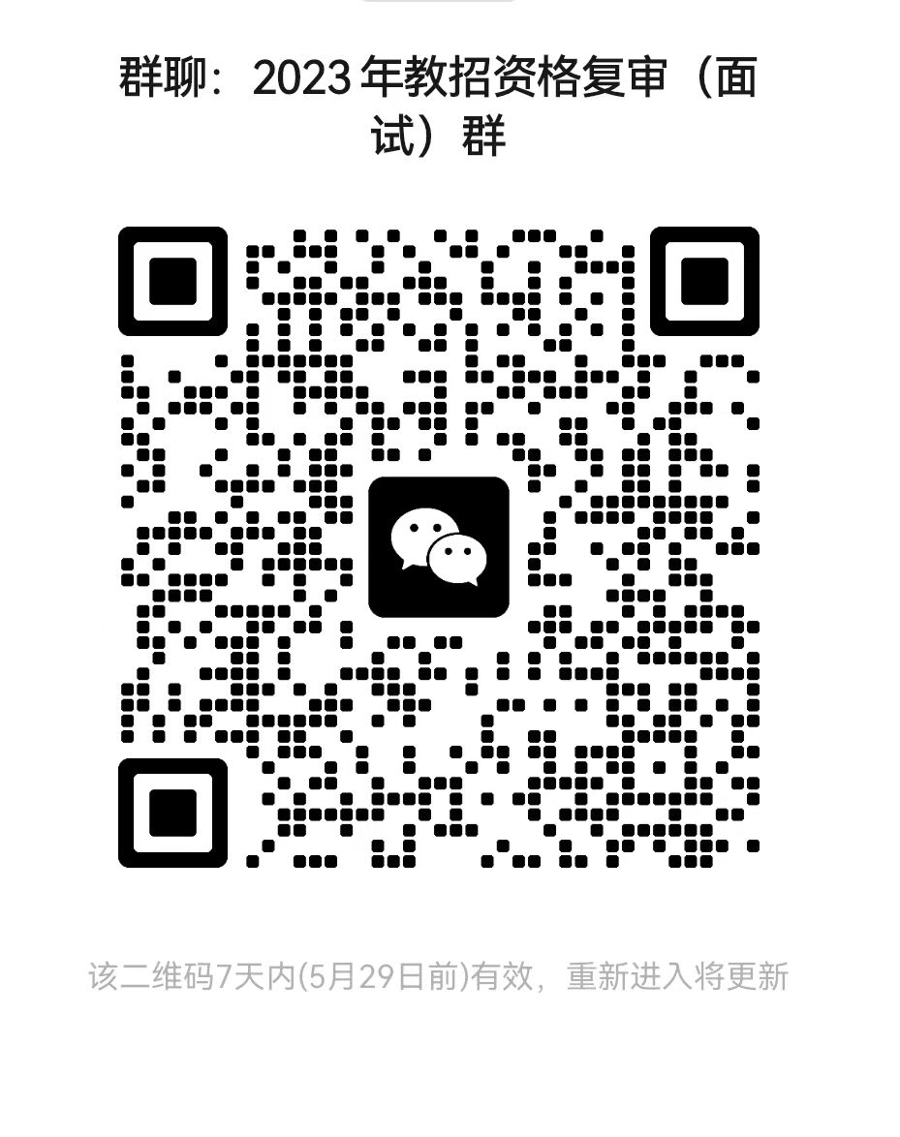
（此件主动公开）

附件下载：

