[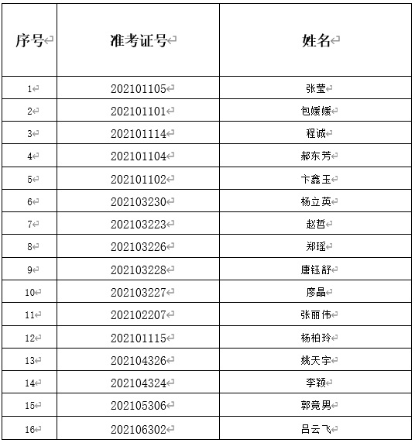](http://www.fxzwedu.com/d/file/xwdt/tzgg/2021-05-26/e29c28558c2339e1cf5ddc43e94a34b9.jpg)