[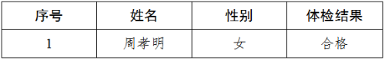](http://nykfq.taizhou.gov.cn/picture/0/b261d03303764d4ba7d38affebe75f85.png)