[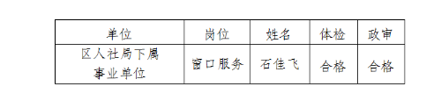](http://www.sxyc.gov.cn/picture/0/c58ed3907ab9457892c1328bbc811d8b.png)