[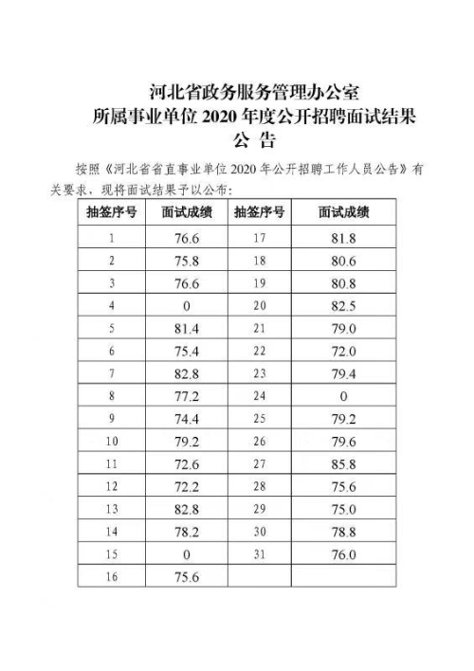](http://www.hbzwfw.gov.cn/picture/0/f286a9359dd5493e976c8200915a9b2b.jpg)