**招聘岗位及要求**  
  [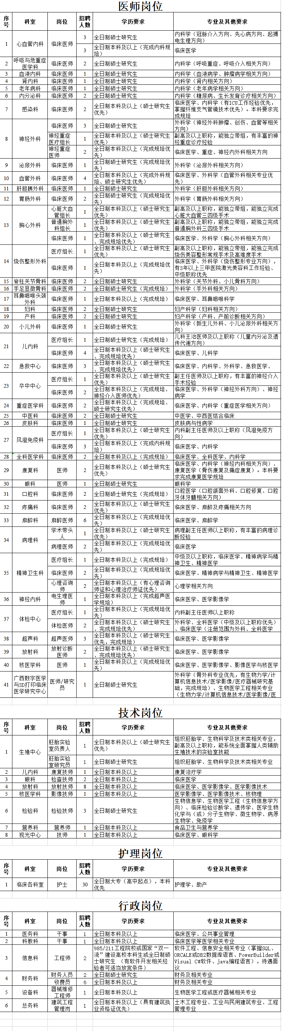](http://www.gghosp.net/Article/UploadFiles/202011/2020111111261932.png)