[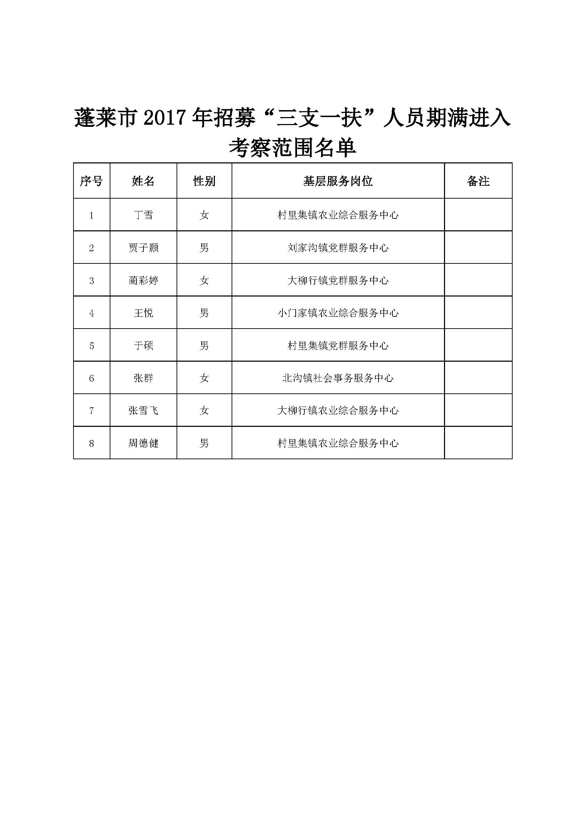](http://www.penglai.gov.cn/picture/0/dc228e9b31194c2ead49f2555bb2a616.jpg)