面试教案—小学英语
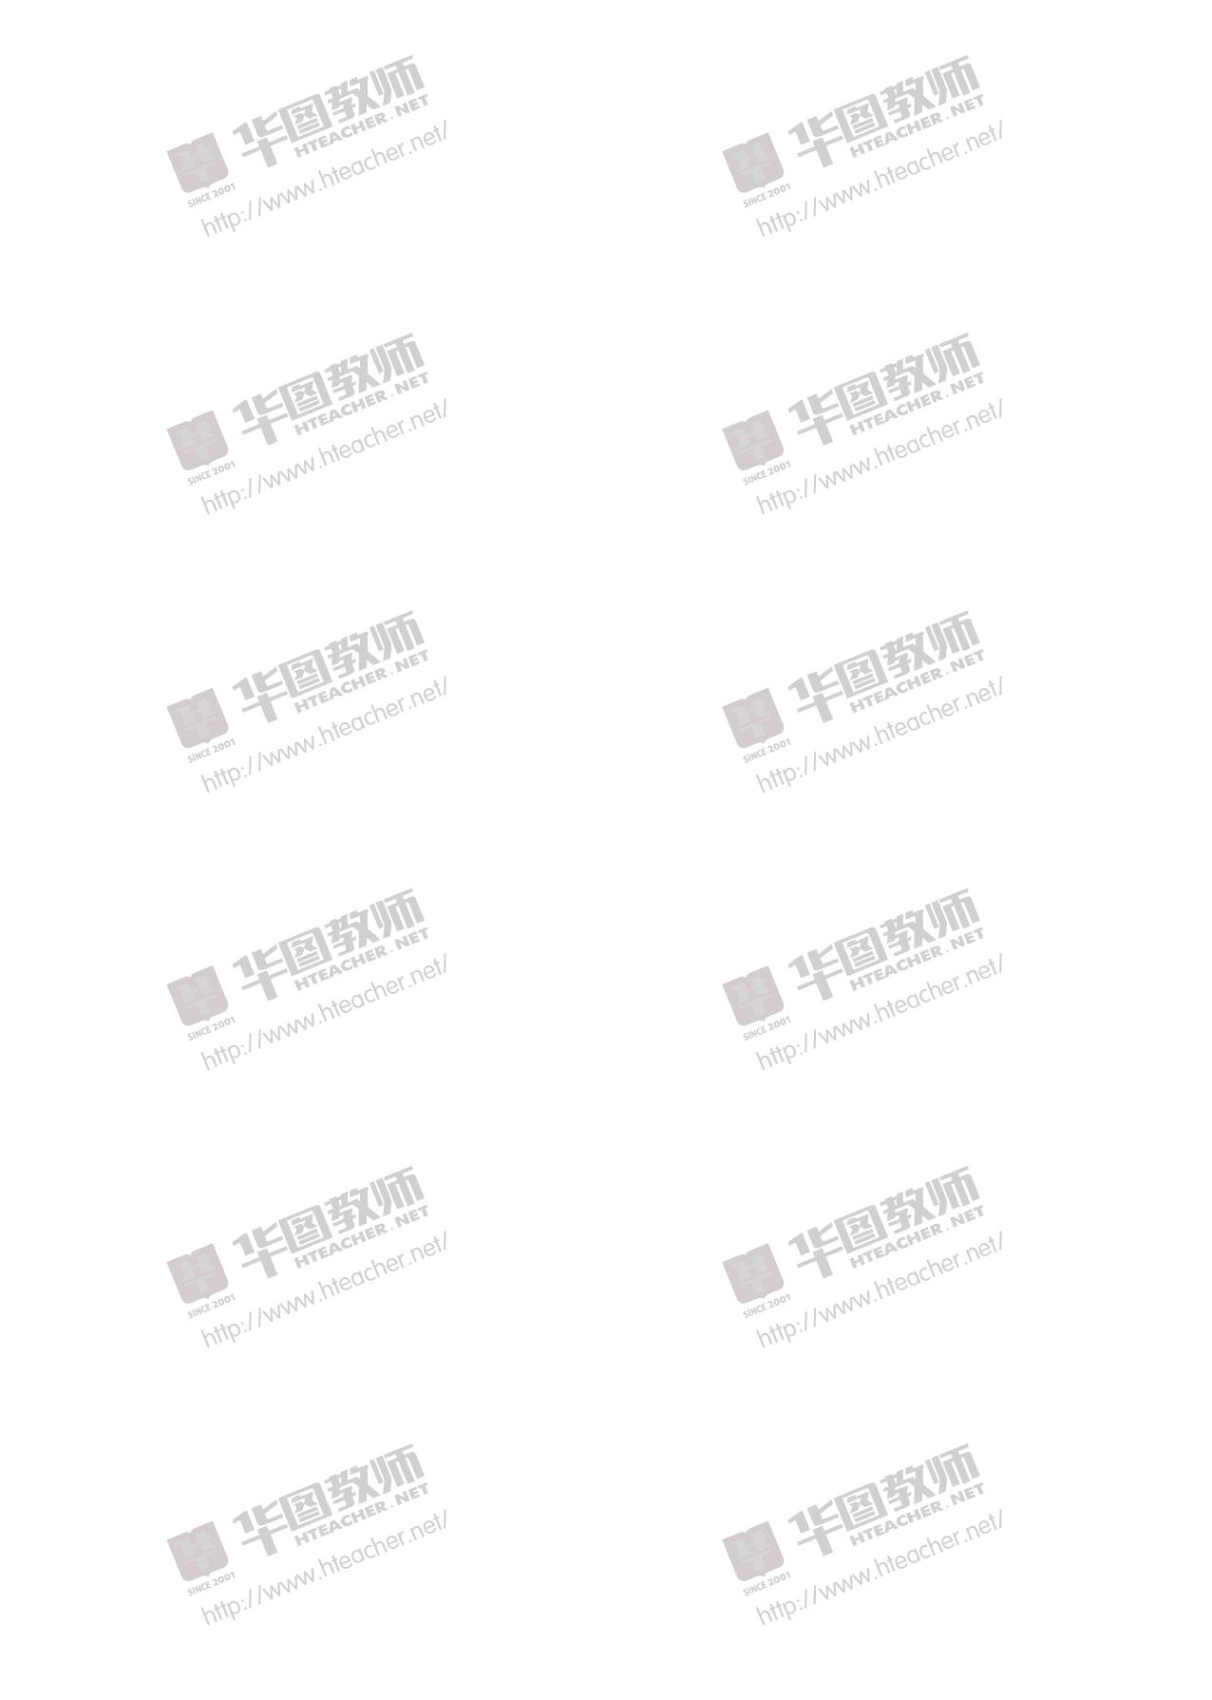

PEP 小学六年级下册《UNIT2 Last Weekend》 | ................................... | 2
PEP 小学六年级下册《UNIT3 Last Weekend》 | ................................... | 5

经典篇目教案集

PEP 小学六年级下册《UNIT2 Last Weekend》
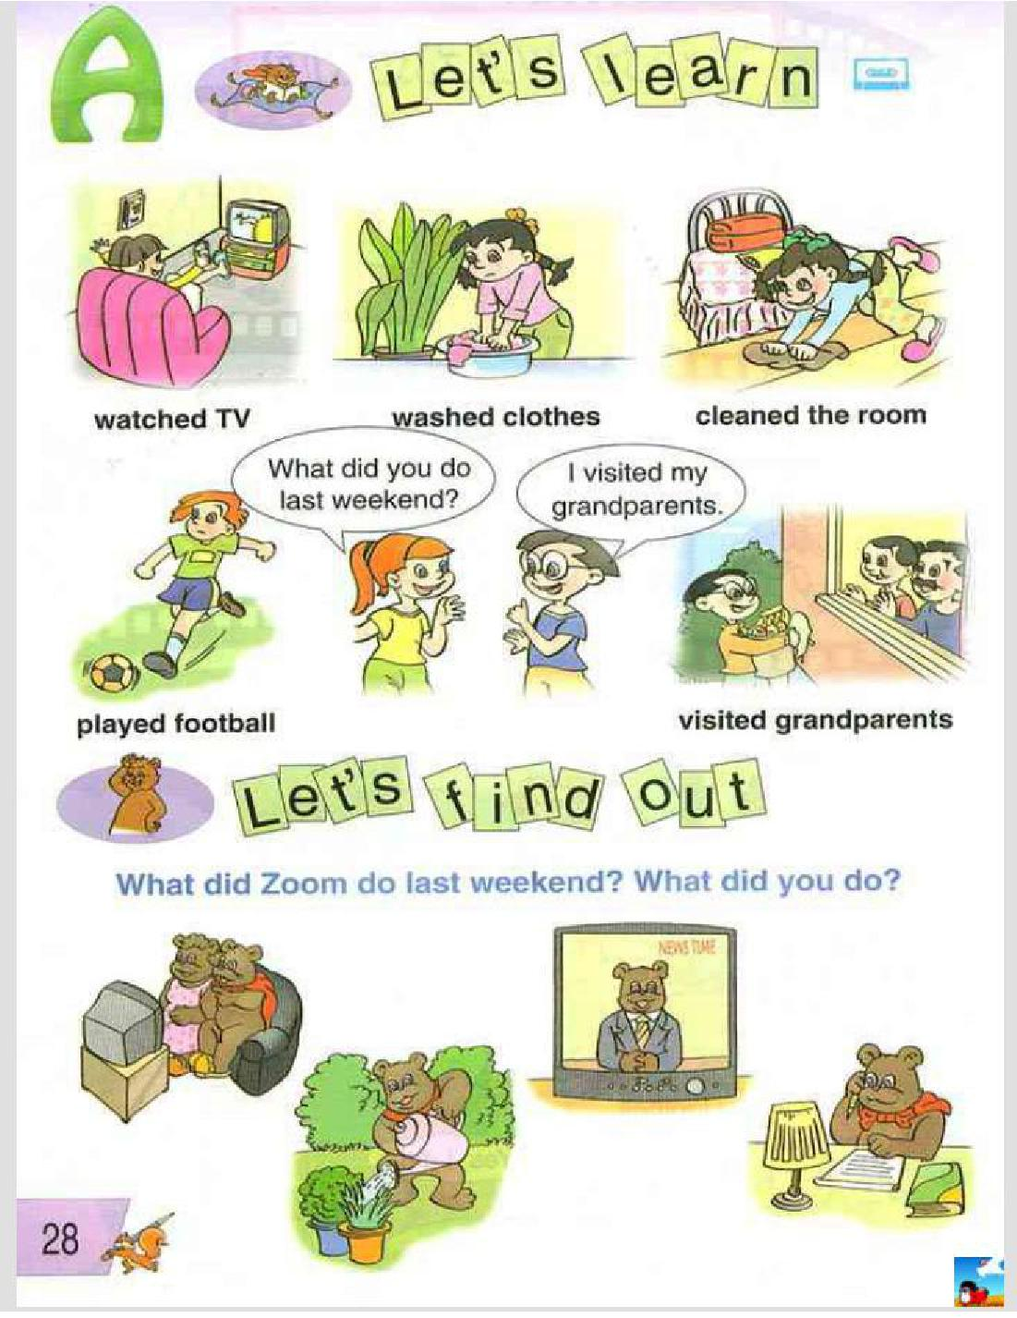

试讲要求：

（1）朗读一遍

（2）设计词汇教学活动

2

经典篇目教案集

（3）适当板书

教学目标

1、能够听、说、读、写短语：watched TV, washed clothes, cleaned the room, played football and visited grandparents。

2、能够听懂问句：What did you do last weekend? 并能够做出正确的回答。3、能够运用新学语言内容完成 Let’s find out 中的任务。教学重点

听、说、读、写短语“watched TV, washed clothes, cleaned the room, played football and visited grandparents”，听懂、会说句子：What did you do last weekend? 并能够在实际情景中灵活运用。

教学难点

- 个词组读音和书写，掌握动词过去式及其发音。

课前准备

1、教师准备本课时所需的六张词卡。

2、教师准备录音机和录音带。

3、教师准备本单元的挂图。

教学过程

1、 Warm-up

（1）Daily oral practice.

Good morning! Glad to meet you. How are you? What’s the weather like today?

对话练习，已学知识的巩固。

（2）Hang–man game. 玩游戏，猜单词。

( watch, wash, clean, play, visit)

2、 Preview

- Let’s chant (第六册书本 Page 7) a. 听一遍录音 b、师生一起说唱

- Let’s start:

What do you usually do on the weekend? 说说自己的周末，复习动词短语。

3、 Presentation

(1)、教师出示一个日历给大家看，圈出今天的日子是 Sunday(weekend)，然后问学生：What’s the date today? What day is it today? 学生回答今天的日期, Today is April the 10th. It’s Sunday.

3

经典篇目教案集

(2)、教师说：On Sunday (weekend)，I usually wash clothes, clean the room, play football, watch TV and visit grandparents.出示教师所说动作的卡片，学

生跟读词组。跟着老师朗读几遍动词短语。

(3)、教师问学生：What do you usually do on Sundays? 学生回答教师的问

题。

(4)、教师再次出示日历，圈出上个星期天的日子，然后问学生：What was

that day? 引导学生回答：It was last Sunday? 板书并带读单词：last。教师：

It was last Sunday. It was the last weekend. 板书、解释并朗读词组： last

weekend。学生跟读并掌握词组：last weekend。

(5)、引出句型：What did you do last weekend?板书句型并朗读。

(6)、呈现词组：watched TV, washed clothes, cleaned the room, played football and visited grandparents.强调这些过去式的发音。/t/, /t/, /d/, /d/, /id/。

(7)、Activity one: Bingo!

(8)、师生问答。（语言内容，媒介）

(9)、Activity two: 摘苹果游戏

(10). 教师领读 Let’s learn 部分。

4、 Consolidation and extension

Let’s find out.

(1)、教师通过 CAI 出示图片，提问：

What did Zoom do last weekend?

板书并认读：do-did, water-watered.

(2)、教师问几个学生：What did you do？

(3)、Do a survey。学生之间相互了解，并做好记录。

完成后上台进行解说。

(4)、填入所缺的单词。

(5)、完成活动手册的相应练习。

(6)、回家朗读课本 Let’s learn 部分，抄写词组。

4

经典篇目教案集

PEP 小学六年级下册《UNIT3 Last Weekend》
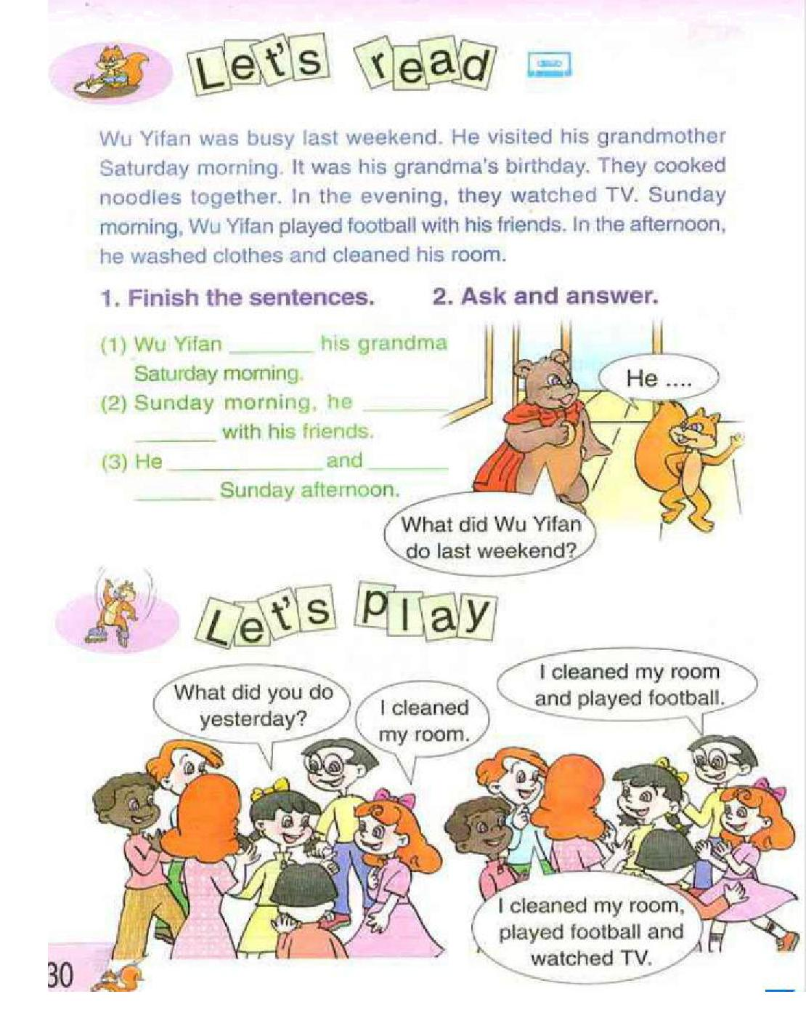

试讲要求：

（1）采用英语授课，试讲时间约 10 分钟；

（2）试讲时需示范朗读教学内容，适当关注语言词调的渗透训练；

5

经典篇目教案集

（3）创设语言情境呈现；

（4）配合教学内容适当进行板书，以帮助学生掌握新学知识点。

教学目标与要求

1、能听、说、认读 Let’s read 部分的内容，并完成相应活动。

2、能够了解双元音音标/ /、/ /、/ /的音与形，能读出例词并选择音标与单词和配图正确连线。

教学重点

1）理解短文内容，学会描述自己或询问他人的周末生活。

2）was, busy, It was …’s birthday.

教学难点

1）理解短文内容，学会描述自己或询问他人的周末生活。

2）was, busy, It was …’s birthday.

课前准备

1、教师准备一幅本课时的教学挂图。

2、教师准备一台录音机和相关录音带。

3、学生准备本课时的单词卡片。

教学过程

1、Warm-up

（1）Let’s sing: The days of the week.

（2）Ask and answer:

What did you do last weekend?

What did you do yesterday?

I ( did) …last weekend/ yesterday.

2、Preview

结合单词卡片复习所学的四会单词，可让学生进行快看快拼的比赛。

3、Presentation

（1）Let’s learn.

从上面的问答中，老师总结并板书呈现：busy, … was busy last weekend.

①根据学生的回答，教师可提出更细节性的问题：

- What did you do last Saturday morning/ last Sunday evening…?

- I (did)…last Saturday morning/ last Sunday evening…

6

经典篇目教案集

- 根据学生 A 的回答，再向其他学生提问：

- What did A do last Saturday morning/ last Sunday evening…?

引导学生将第一人称改为相应的第三人称进行回答，并将学生的回答(选择一个)以短语形式填入课前准备好的表格中。见附录。

②完成表格后，T 再次重复：

A was busy last weekend.

③ 根据板书及表格，引导其他学生以：

××× was busy last weekend.

为开头转述其他同学上周周末的活动。（2）Presentation of the sentences

① T: A was busy last weekend. B was busy last weekend. And Wu Yifan was busy last weekend, too.（可用课件展示）

② Now, let’s listen to the short passage and answer some questions.( T 可根

据段落内容顺序设计问题)

- Whom did he visit? Why?

- What did they do together?

- What did they do in the evening?

- What did Wu Yifan do Sunday morning? With whom?

- What did Wu Yifan do in the afternoon?

- 听完两遍录音，学生可以同桌讨论并回答问题。如果有不同答案，大家一起讨论，寻求最佳答案。

④ 听音跟读，再齐读。

⑤ 要求学生独立完成课本中“Finish the sentences”. 再进行组内讨论并校

对答案。

1) Let’s play

T: Look at the calendar. Today is ( date ).

Yesterday was (date).

What did you do yesterday?

- I (did) yesterday. 2) Activity 1 :滚雪球

Pronunciation

7

经典篇目教案集
（1）听音模仿. 教师要以夸张的口型带学生跟读。

（2）认读双元音音标。/ / , / /, / /.说明音标与字母的区别和联系。

- 拼读单词。老师请学生自己拼读并读给大家听。

- 读单词，连线。

- Activity 2: Play basketball

4、Consolidation and extension

（1）用词组或短句来描述自己爸爸或妈妈上周末的活动情况。

（2）完成活动手册相关内容。

….

