面试教案—初中英语

.......................................................... | 2
What time do you go to school
_{Where is your pen pal from?}............................................................... | 7

经典篇目教案集

What time do you go to school
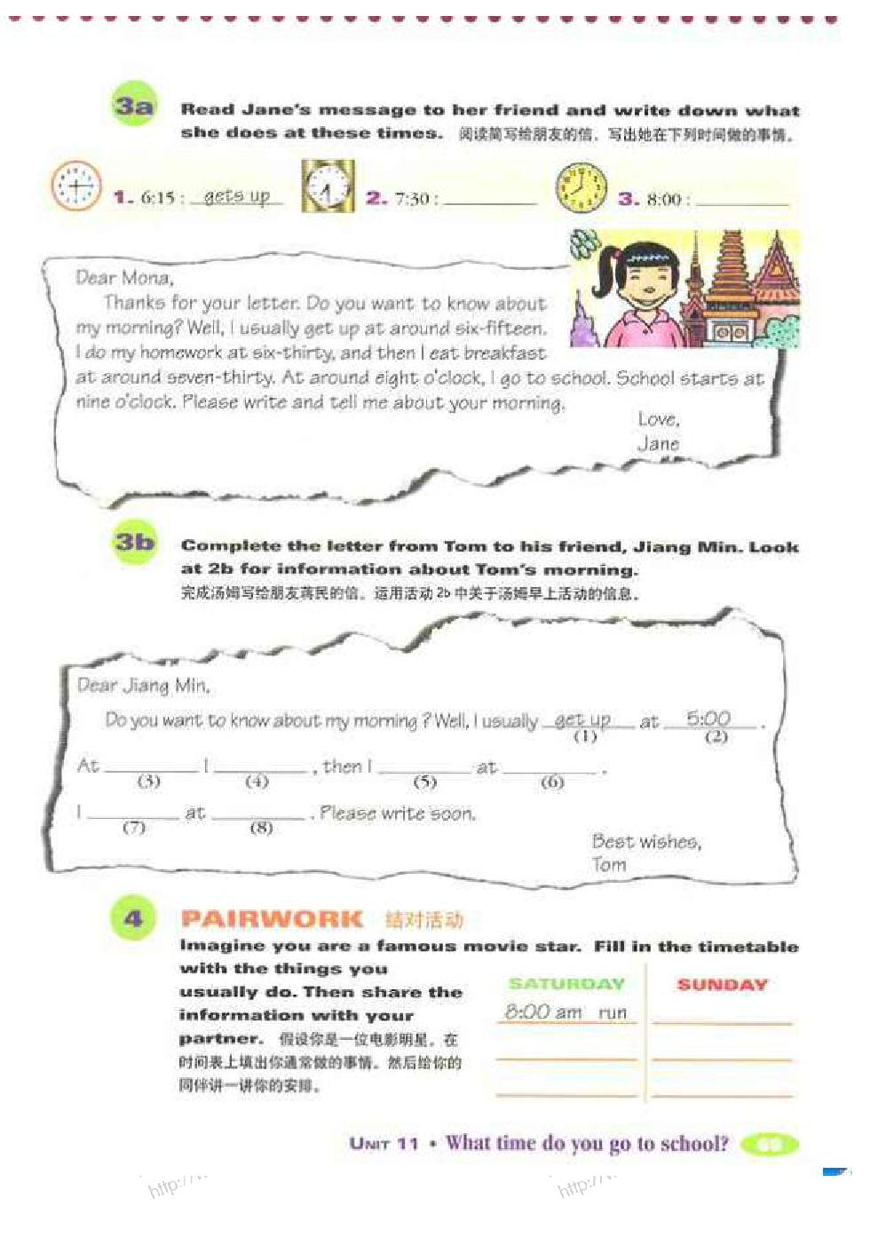

2

经典篇目教案集

试讲要求：

（1）朗读一遍

（2）设计阅读教学活动

（3）适当板书

Class Type: reading class

Period: Section B:3a-4

Teaching Objectives

1. Knowledge objectives

Grasp the phrases like get up, go to school, eat breakfast, do homework…

Be able to master the sentence pattern Sb. either do/does…or do/does

Enable Ss to understand the meaning of usually, always and sometimes and use these words to describe their daily life.

2. Ability objectives

Learn to use the passage to guess the meaning of usually, always and sometimes.

Be able to understand the main idea and some details of the dialogues by skimming, scanning and intensive reading.

3. Moral objectives

Enhance Ss’ awareness of the importance of learning to do time planning and have a good habit.

Teaching Key Points

- Review some phrases and understand the passage.

- Be able to master the reading skills of skimming, scanning and intensive reading.

3

经典篇目教案集

Teaching Difficult Points

Enhance Ss’ awareness of the importance of learning to do time planning and have a good habit.

Teaching Procedures

Step 1 Warming up & leading in

Show Ss a video clip of a human’s daily life from getting

up to fall asleep.

After watching the video, divide Ss into 4 groups to discuss

the following question. Then report the results to the teacher.

T: Do you think this human’s day is good or not?

S1: … S2: …

Step 2 Pre-reading

Show the pictures of Tony and Mary and ask Ss to guess what

their daily lives are.

Firstly, teacher introduces some habits of them.

Secondly, ask Ss to guess.

- Which ones do you think belong to Tony and which one belong

to Mary?

S1:S2:

Step 3 While- reading

Task 1 Skimming

1. True or False

Make a form and list some simple sentences extracted from the passage and Ss should finish it by themselves.

- Then ask some Ss to write their answers on the blackboard

4

经典篇目教案集

and the one who gives all right answers gets some bonus.

Questions True False

Tony like eats hamburgers.

When Tony gets home, he watches TV

first.

…

Task 2 Scanning

- Guess the meaning of usually, always and sometimes.

- Listing

Ask Ss to list Tony and Mary’s habits under their names.

Tony Mary

Task 3 Intensive Reading

- Help Ss to understand the sentence pattern Sb. either do/does…or do/does and ask Ss to make up new sentences.

- Ask Ss to draw schedules for Mary and Tony in groups and present it in front of the whole class. Pay attention to different Ss and encourage them to join in the activity.

- Read out loud the passage together.

Step 4 Post-reading

Organize a little drama on the topic of “A day of my life”. Phrases and sentence pattern learned should be used in their presentation.

Step 5 Summary

Ss will summarize the language points learned in this lesson

5

经典篇目教案集

and teacher makes supplement timely.

T stresses that Ss should arrange their time well in daily life and to be a good time planner.

Step 6 Homework

Ss are encouraged to make a time schedule of one day by themselves. They are supposed to share the schedule in next class.

6

经典篇目教案集

Where is your pen pal from?

试讲要求：

（1）朗读一遍

（2）设计语法教学活动

（3）适当板书

Topic: Countries, nationalities, and languages

Period：1a----Grammar Focus

Teaching Aims:

Knowledge Aim:

Ss can use the words about countries, languages. Talk about countries, nationalities and languages. Ask and tell about where people live

Ability Aim:

Where is she from? She is from....

Where does she live? She lives in....

What language does she speak? She speaks....

Emotional Aim:

Forster Ss’ sense of cultural awareness. To motivate ss’ cross-culture communication skills.

Key points:

7

经典篇目教案集

Where is your/John's pen pal from? He/She is from...

Difficult points:

Pay attention to the “s” in third person singular.

e.g. Where does he/she live? He/She lives in....

Teaching Steps:

Step 1 Leading-in

The information of the teacher's own pen pal's information.

"I have a pen pal. His name is Curry Murray. He is from the United States. Do you have a pen pal? Where is your pen pal from? What's your pen pal's name?"

Different students say the information about their own pen pals. T should choose the different countries. T writes the different countries on the Bb(both Chinese and English)

Step 2 Learning

Section A 1a

Learn the new words on the Bb. The new words are:

pen pal; Canada; France; Japan; the United States(the US/the USA/America); Australia; Singapore; the United Kingdom(the U.K./Great Britain/England)

Pay attention to the pronunciation of the new words.

Step 3 Listening

1b Listen and circle the countries in 1a they learned

8

经典篇目教案集

Step 4 Competition

Two groups of students to write the new words to see which group does better. First write down the Chinese words with looking at the English meanings, then write down the English words with looking at the Chinese meanings.

(This step is a memory game. It can help the Ss consolidate the new words they learned)

Step 5 Pair work

1c Practice the following conversation:

---Do you have a pen pal? ---Yes, I do.

---Where's your pen pal's from? ----He/She is from ....(Write it

on the Bb)

First T has a conversation with one student as an example then let the Ss practice in pairs. At last let several pairs do it again in class.

Step 6 Leading-in

Revise the countries names with looking at the Bb. Then T writes down the city names on the Bb. Let the Ss try to find out which countries the cities are in. The city names are following: Toronto; Paris; Tokyo; New York; Sydney; Singapore; London;

9

经典篇目教案集

Step 7 Learning

2a Learn the city names together with the whole class just like Step 2

2b Listen and circle the cities and countries

2c Listen and complete the chart

Have a similar competition to consolidate the new words in this part.

Step 8 Pair work

T has a conversation with one student like the following:

---Do you have a pen pal? ---Yes, I do.

---What's your pen pal's name? ---His/Her name is....

---Where is your pen pal from? ---He/She is from...

---Where does he/she live? ---He/She lives in....(Write it down

on the Bb)

Let the Ss practise after the T's example in pairs then several pairs do it in class.

Step 9 Exercise

My pen pal is from Australia.(划线提问)

John's pen pal is from Japan. (划线提问)

He lives in Paris. (划线提问)

Homework:

Read and copy the new words .

Copy the sentences in Grammar Focus

10

经典篇目教案集

Make up the questions about Jodie in 2c The questions are:

Does Jodie have a pen pal? Where is Jodie's pen pal from? Where does he/she live? What's his/her name?(This one can be chosen by themselves)

