[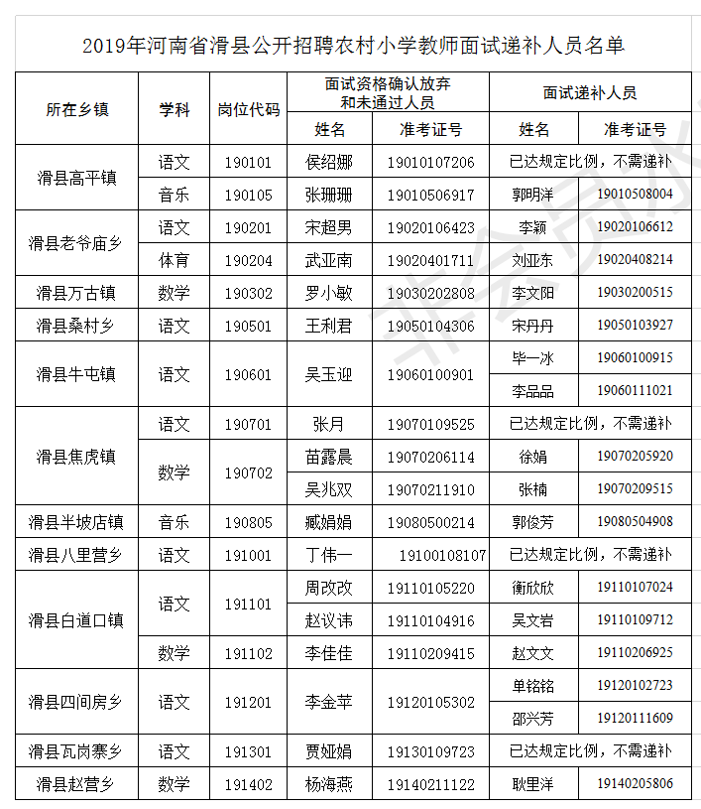](http://hahuaxian.hrss.gov.cn/d/file/xinwenzixun/gonggaogongshi/2019-08-20/9039cfcf568079865a09de15a0e2d039.png)