[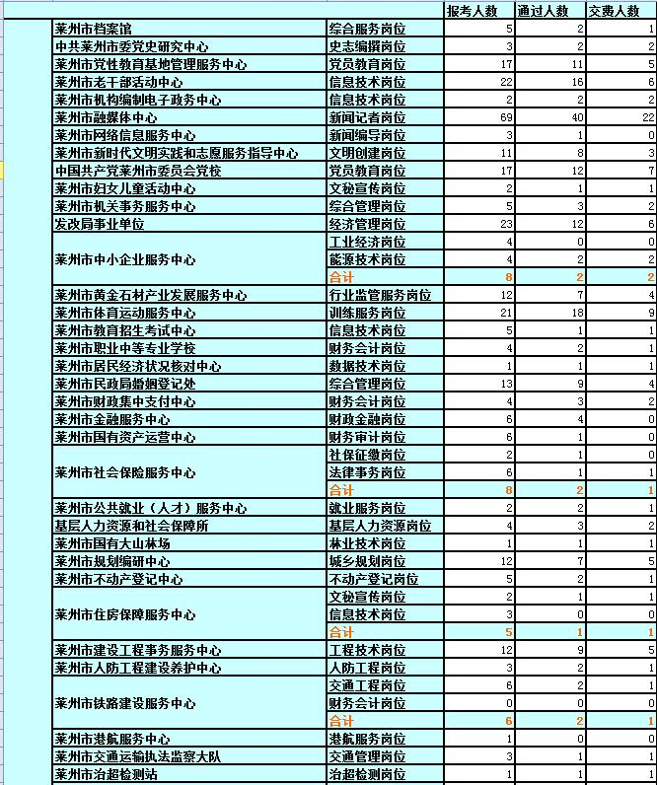](http://www.laizhou.gov.cn/picture/0/ac694a9fd03b43818203c866bc2f6fee.jpg)

[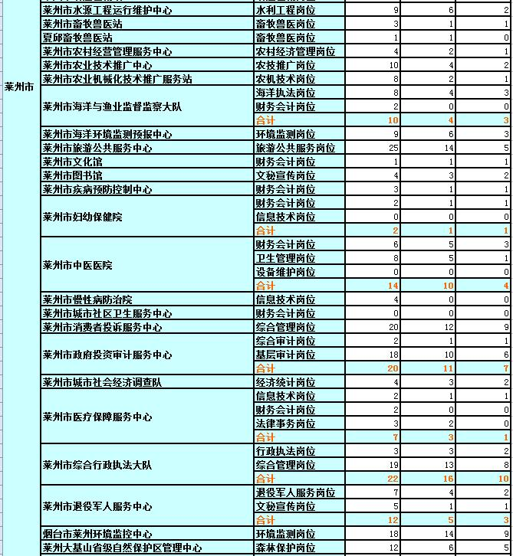](http://www.laizhou.gov.cn/picture/0/1a79fbdb587448c7967d3d306cf795f2.jpg)

[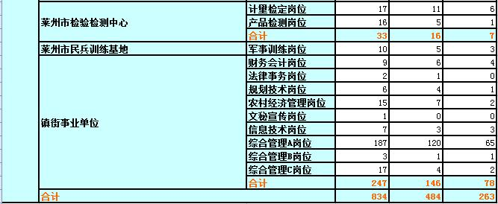](http://www.laizhou.gov.cn/picture/0/c1b1aee1b6f34dcf9f32c5e0e05d5aa0.jpg)