[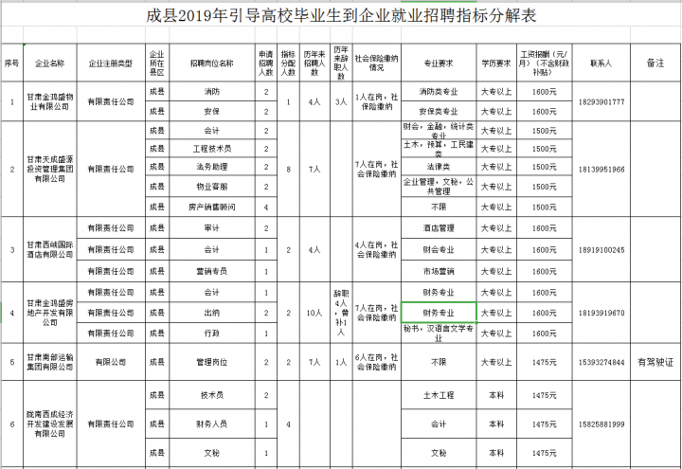](http://www.gscx.gov.cn/attachment/sites/item/2019_08/06_19/7f0a553fc59b9bec.png)

[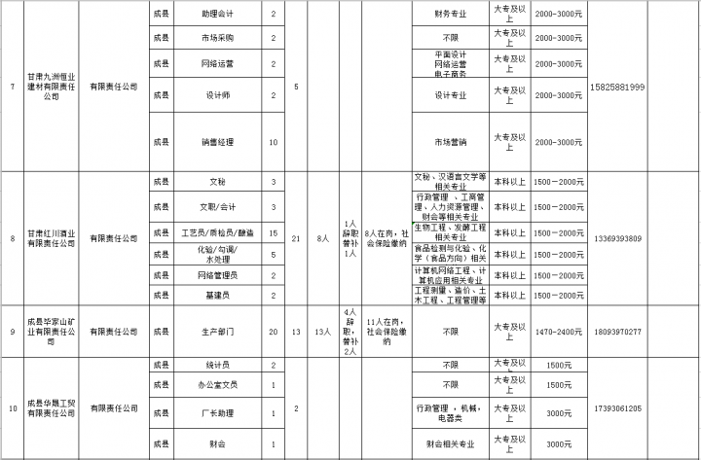](http://www.gscx.gov.cn/attachment/sites/item/2019_08/06_19/98f945b8c8b72156.png)

[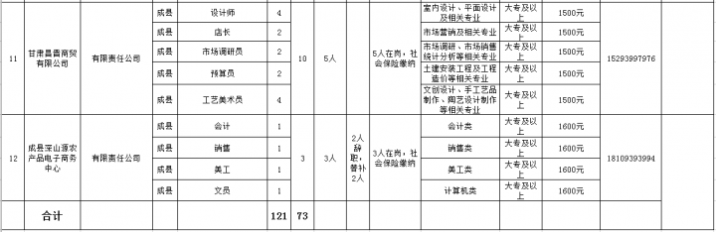](http://www.gscx.gov.cn/attachment/sites/item/2019_08/06_19/3d73e026f3604a46.png)